Acceptance tests   
“Acme Rookies v1.0”

|  |  |
| --- | --- |
| Development team | |
| **Identifier** | *G92* |
| **Members** | *Batista Núñez, Francisco.*  *de la Flor Bonilla, Álvaro.*  *Fernández Benjumea, Carmen.*  *Ferrete Molle, José Antonio.*  *Salvat Pérez, Antonio Manuel.*  *Sanchez Hipona, Antonio.* |
| **Testing team** | |
| **Identifier** |  |
| **Members** |  |
| **Indexing data** | |
| **Test designers** | *Salvat Pérez, Antonio Manuel.*  *If you need to contact me:*  *antoniosalvatperez@gmail.com*  *+34 673 53 28 89* |
| **Testers** |  |
| **Notes** | *Use cases of R23.2* |

**Table of contents**

Use case 23.2.1: Logged , send a message 3

# Use case 24.1: Logged , send a notification message

Description

An user logged like an admin must be able to send a notification

Access

First, the user must log in the login page. User: admin, Password: admin

The steps to follow are explained down.

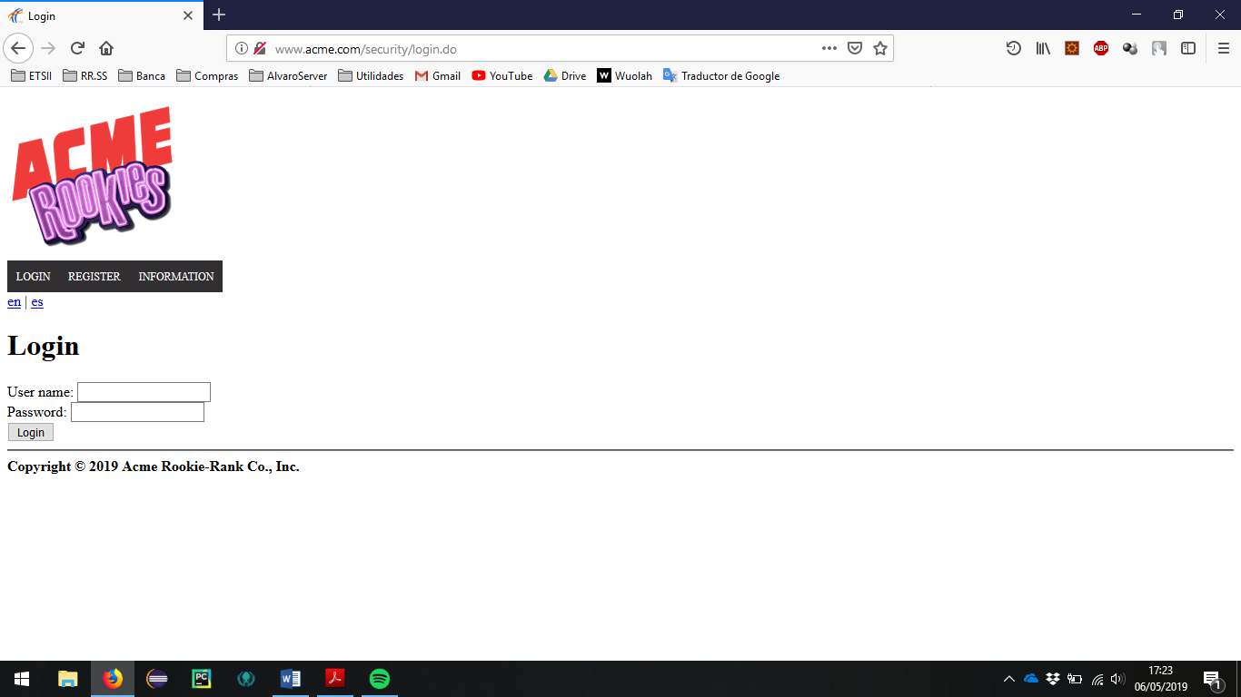

Go to the section of user profile.

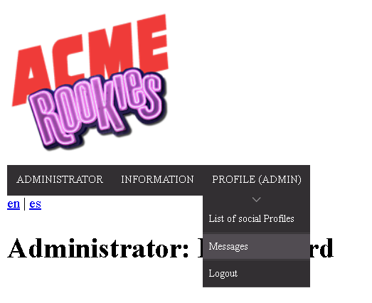

> Header Menu > Display the "PROFILE" options > Messages

The list of sended messages and received messages should appear. The lists are empty because there aren´t messages in the populate.

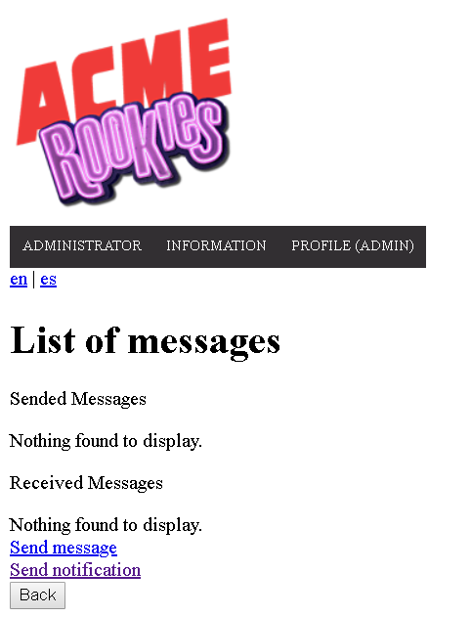

The user must click on the button “Send notification” to redirect to the view of sending a message. In this view we find two fields, one for the subject of the message, and one for the body.

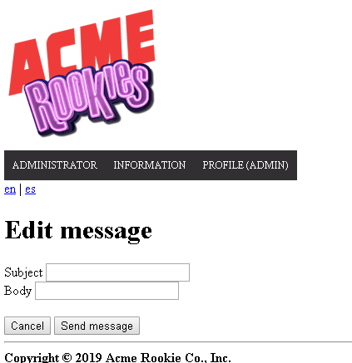

Tests

|  |  |
| --- | --- |
| Test 1 | |
| **Description** | Click on the button to create a new message and fill it with invalid data. |
| **Expected** | A form with two fields must appear, being the 2 completeness mandatory.  After sending the form with erroneous fields, the error messages should appear right next to the field that they have completed in the wrong way and the message should not be saved under any circumstances if an error is still present. |
| **Outcome** |  |
| **Notes** |  |

|  |  |
| --- | --- |
| Test 2 | |
| **Description** | Re-complete the previous form but with valid data. |
| **Expected** | If all the fields have been completed correctly the system will send the message and redirect to the list view of the messages.  Make sure that all the fields are correct. |
| **Outcome** |  |
| **Notes** |  |

|  |  |
| --- | --- |
| Test 3 | |
| **Description** | Correct listing. |
| **Expected** | Check that the list of message is correct and make sure that the new message created now appears. The tag “SYSTEM” should be put automatically. |
| **Outcome** |  |
| **Notes** |  |

|  |  |
| --- | --- |
| Test 4 | |
| **Description** | Show message |
| **Expected** | Click the subject to redirect at the show of a message.Check that the data of the message is correct with all the recipients. |
| **Outcome** |  |
| **Notes** |  |

|  |  |
| --- | --- |
| Test 5 | |
| **Description** | Try to do GET hacking to the system (I). |
| **Expected** | Copy the edit URLs, and try to enter to the show of a meesage. Try it without login and with an actor who is neither the one who sends it nor the one who receives it. In this case the recipient are all of the actors  Depending on the populate the id of the message may vary so to make sure you have that id you would have to enter the show of that message before and see its url  You can use, as an example:  /message/show.do?messageId=32770  Being 32770 the ID of the entity to edit.  The system must redirect to the start tab or to the log in view in the case of a not login |
| **Outcome** |  |
| **Notes** |  |